**LAB-3**

**Prepare Lab Sheet of MYSQL Statements for following. Use the Company Database in Lab-1 and Lab-2.**

1. Select the names of employees and their dependents without using JOIN.

Ans:

**Query:**  
mysql> SELECT E.Ename AS EmployeeName, D.Dname AS DependentName FROM Employee E, Dependents D WHERE E.SSN = D.SSN;

**Result:**

+--------------+---------------+

| EmployeeName | DependentName |

+--------------+---------------+

| SuraJ | himesh |

| SuraJ | yam |

| hari | sima |

| Ram | krinjal |

| Sita | basu |

+--------------+---------------+

5 rows in set (0.00 sec)

1. Select the names of employees and their dependents without using INNER JOIN and order the result based on dependents name.

Ans:

**Query:**

mysql> SELECT E.Ename AS EmployeeName, D.Dname AS DependentName FROM Employee E, Dependents D WHERE E.SSN = D.SSN ORDER BY D.Dname;

**Result:**

+--------------+---------------+

| EmployeeName | DependentName |

+--------------+---------------+

| Sita | basu |

| SuraJ | himesh |

| Ram | krinjal |

| hari | sima |

| SuraJ | yam |

+--------------+---------------+

5 rows in set (0.00 sec)

1. Use JOIN between Employee, Project and Works_on and retrieve the name of employees and the projects on which they work.

Ans:

**Query:**

SELECT E.Ename AS EmployeeName, P.Pname AS ProjectName FROM Employee E JOIN Works_on W ON E.SSN = W.ESSN JOIN Project P ON W.PNO = P.Pnumber;

**Result:**

+--------------+-------------------+

| EmployeeName | ProjectName |

+--------------+-------------------+

| SuraJ | Hari_ProjMDS |

| hari | Sita_ProjMDS |

| Ram | pratiksha_ProjMDS |

| Sita | Ram_ProjMDS |

| pratiksha | Suraj_ProjMDS |

+--------------+-------------------+

5 rows in set (0.01 sec)

1. Use Inner join between Employee and PF table with the join condition, Employee.SSN=PF.SSN and Employee.Salary>PF.Amount

Ans:

**Query:**

mysql> SELECT E.Ename, PF.PFCategoryName FROM Employee E INNER JOIN PF ON E.SSN = PF.SSN WHERE E.Salary > PF.Amount;

**Result:**

+-----------+----------------+

| Ename | PFCategoryName |

+-----------+----------------+

| SuraJ | Category 1 |

| SuraJ | Category 1 |

| hari | Category 2 |

| hari | Category 2 |

| Ram | Category 3 |

| Ram | Category 3 |

| Sita | Category 4 |

| Sita | Category 4 |

| pratiksha | Category 5 |

| pratiksha | Category 5 |

+-----------+----------------+

10 rows in set (0.00 sec)

1. Write a query to show the results of Left and Right Join between Office and Project.

Ans:

**Query:**

**Left join:**

mysql> SELECT *FROM Office LEFT JOIN Project ON Office.Onumber = Project.Onumber;

**right join:**

mysql> SELECT * FROM Office RIGHT JOIN Project ON Office.Onumber = Project.Onumber;

**Result:**

+---------+-----------------+-----------+---------+-------------------+---------------+---------+

| Onumber | Oname | Country | Pnumber | Pname | Proj_location | Onumber |

+---------+-----------------+-----------+---------+-------------------+---------------+---------+

| 1 | Suraj_Office_38 | USA | 76 | Suraj_ProjMDS | lalitpur | 1 |

| 2 | Suraj_ntc_38 | UK | 20 | Hari_ProjMDS | bhaktapur | 2 |

| 3 | hari_Office_06 | Nepal | 21 | Sita_ProjMDS | australia | 3 |

| 4 | Ram_Ncell_06 | china | 22 | pratiksha_ProjMDS | bhaktapur | 4 |

| 5 | Sita_Ncell_06 | australia | 23 | Ram_ProjMDS | ktm-2 | 5 |

+---------+-----------------+-----------+---------+-------------------+---------------+---------+

5 rows in set (0.01 sec)

**RightJoin**:

+---------+-----------------+-----------+---------+-------------------+---------------+---------+

| Onumber | Oname | Country | Pnumber | Pname | Proj_location | Onumber |

+---------+-----------------+-----------+---------+-------------------+---------------+---------+

| 2 | Suraj_ntc_38 | UK | 20 | Hari_ProjMDS | bhaktapur | 2 |

| 3 | hari_Office_06 | Nepal | 21 | Sita_ProjMDS | australia | 3 |

| 4 | Ram_Ncell_06 | china | 22 | pratiksha_ProjMDS | bhaktapur | 4 |

| 5 | Sita_Ncell_06 | australia | 23 | Ram_ProjMDS | ktm-2 | 5 |

| 1 | Suraj_Office_38 | USA | 76 | Suraj_ProjMDS | lalitpur | 1 |

+---------+-----------------+-----------+---------+-------------------+---------------+---------+

5 rows in set (0.00 sec)

1. Write a query to show the results of Cross Join between Employee and PF tables.

Ans:

**Query:**

mysql> SELECT *FROM Employee CROSS JOIN PF;

**Result:**

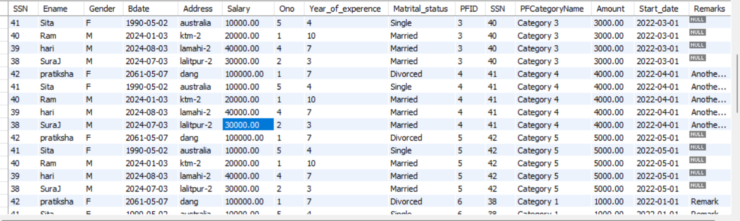

50 rows in set (0.02 sec)

1. Show results of using natural join between Employee and PF.

Ans:

**Query:**

SELECT *FROM Employee NATURAL JOIN PF;

**Result:**

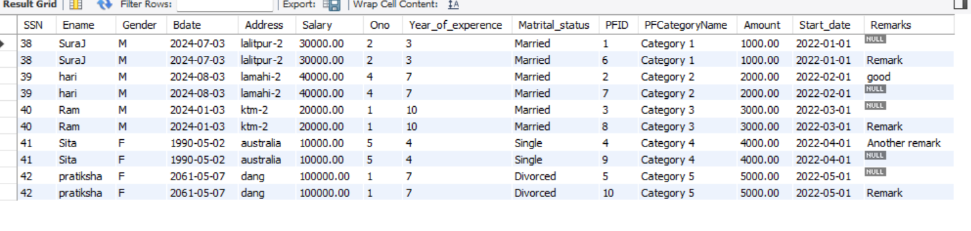

1. Find the number of employees and status in each status of “Married”, “Single”, “Divorced”. Use the COUNT function with the GROUP BY clause with status.

Ans:

**Query:**

mysql> SELECT Marital_status, COUNT(*) AS Count FROM employee GROUP BY Marital_status;

**Result:**

+----------------+-------+

| Marital_status | Count |

+----------------+-------+

| Married | 3 |

| Single | 1 |

| Divorced | 1 |

+----------------+-------+

3 rows in set (0.00 sec)

1. Find the number of employees and status in each status of “Married” OR “Single”. Use the COUNT function with the GROUP BY clause with status and Having clause with status = “Married” OR “Single”

Ans:

**Query:**

mysql> SELECT Marital_status, COUNT(*) AS Count FROM Employee GROUP BY Marital_status HAVING Marital_status = 'Married' OR Marital_status = 'Single';

**Result:**

+----------------+-------+

| Marital_status | Count |

+----------------+-------+

| Married | 3 |

| Single | 1 |

+----------------+-------+

2 rows in set (0.01 sec)

1. Using sub query, select the name and location of projects whose Onumber is in the Onumber of the offices located in country Nepal and India.

Ans:

**Query:**

SELECT P.Pname, P.Proj_location FROM Project P WHERE P.Onumber IN (

SELECT O.Onumber

FROM Office O

WHERE O.Country IN ('Nepal', 'India')

);

**Result:**

+--------------+---------------+

| Pname | Proj_location |

+--------------+---------------+

| Sita_ProjMDS | australia |

+--------------+---------------+

1 row in set (0.00 sec)